WRITE UP


%Advance Computer Vision
%Due Date: 12/04/2012
%Homework #1
%Authors: Karina Damico & Piter Garcia

%Loading image, converting to double, then to grayscale and displaying.
I = im2double(I);
IGray = rgb2gray(I);
figure,imshow(IGray); suptitle('Gray Scale Picture');

%Extracting patch from image as well as the Strip that contains it.
patch1 = IGray(80:110,200:230);
Strip = IGray(80:110,1:450);

Image was loaded, converted to double and then to a gray scale. This made possible for us to assign any desired patch from the loaded image while applying the Normalized Cross Correlation. Afterwards, patch dimensions were assigned as well as the strip that contains the patch. These values were obtained manually, by observation.

%Calculating Error from the patch and strip selected and plotting it.
stripe=IGray(80:110,:);
figure,imshow(stripe);

[M N]=size(patch1);
sz=size(stripe,2);
err=zeros(1,sz);

for i=1:1:sz-N
test=stripe(:,i:i+N-1);
err(i)=sum(abs(test(:)- patch1(:)));
end
%finding min and index of values
[mini k]=min(err);
plot(err), grid, hold on;
xlabel('Column Position');
ylabel('Error');
suptitle('Total Absolute Error');

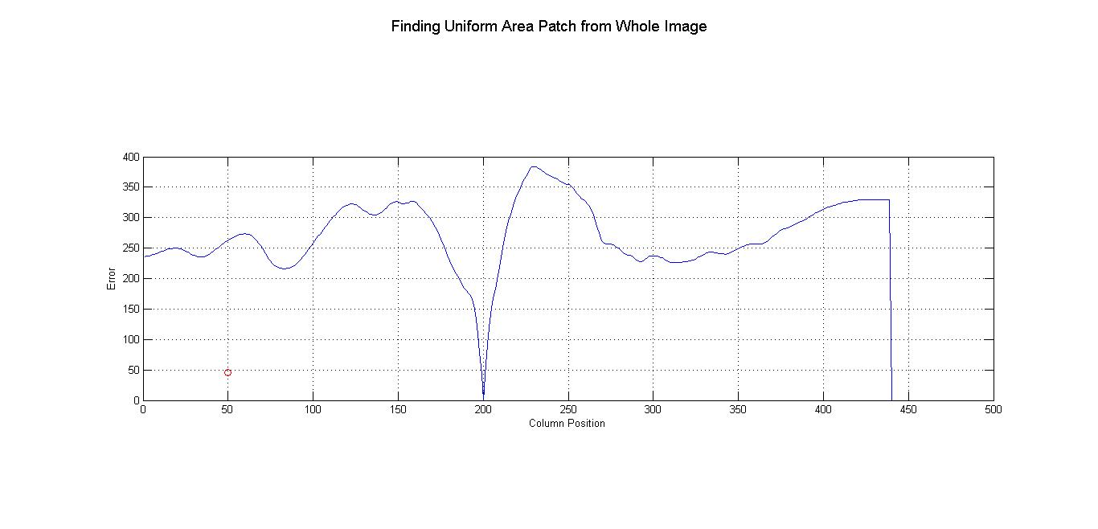

After the patch was assigned and the strip manually obtained, we proceeded to the difference of these two by adding up the absolute different between one another. The result of this was plotted and shown above.

% Patch Normalized Cross Correlation on Strip
figure,
g = normxcorr2(patch1, Strip);
d = abs(g);
[ypeak, xpeak] = find(d == max(d(:)));
ypeak = ypeak-(size(patch1,1)-1)/2;
xpeak = xpeak-(size(patch1,2)-1)/2;
fprintf('\n Center of patch: ypeak is %d and xpeak is %d \n\n\n', ypeak, xpeak);
subplot(2,1,1),imshow(Strip),title('Finding Patch from Strip');
hold on;
plot(xpeak, ypeak, 'ro');
subplot(2,1,2),surf(g), shading flat,title('Grapth of Patch from Strip');
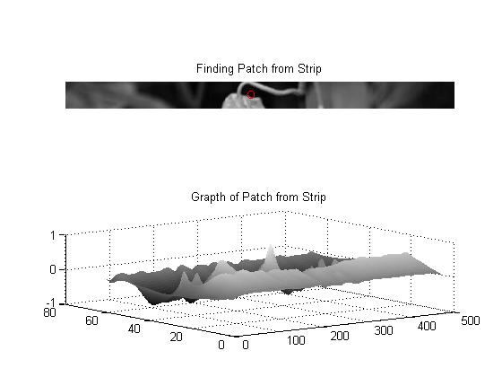
Once the error was calculated, the strip previously assigned was used to find the manually assigned patch. Also, a 3D graph was built from the patch in order to distinguish the maximum points in the image to use this as a reference for future patches. Moreover, we decided to build a function that takes a patch as an input, along with the image it comes from, and applies the normalized cross correlation to the input patch on the given image.
%Displaying patch and the strip that contains the patch selected.
figure,
subplot(2,1,2),imshow(patch1), title('Patch Selected from Picture');
subplot(2,1,1),imshow(Strip), title('Strip Containing Patch from Picture');
suptitle('Patch & Strip');
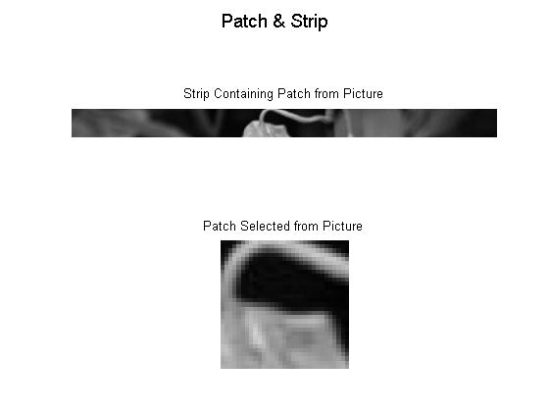

This is a demonstration of how the previous assigned patch and also the strip that contains it look.

function [ newtemplate ] = templates(patch1, IGray);
%template = .2*ones(11); % make light gray plus on dark gray background
g = normxcorr2(patch1, IGray);
d = abs(g);
[ypeak, xpeak] = find(d == max(d(:)));
ypeak = ypeak-(size(patch1,1)-1)/2;
xpeak = xpeak-(size(patch1,2)-1)/2;
fprintf('\n Center of patch: ypeak is %d and xpeak is %d \n\n\n', ypeak, xpeak);
figure,imshow(IGray);
figure, surf(g), shading flat, title('Graph Of Selected Patch');
hold on;
plot(xpeak, ypeak, 'ro');

newtemplate = g;
end

Once the error was calculated, the strip previously assigned was used to find the manually assigned patch. Also, a 3D graph was built from the patch in order to distinguish the maximum points in the image to use this as a reference for future patches.


% Patch Normalized Cross Correlation on Whole Image.
templates(patch1, IGray);
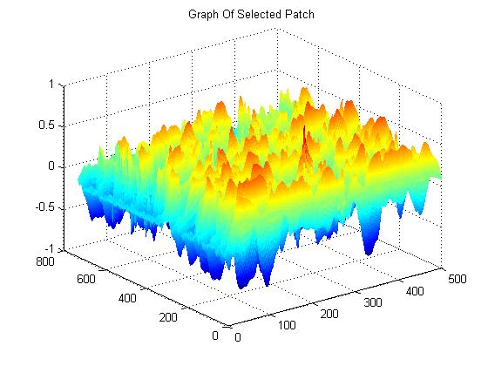
suptitle('Finding Patch from Whole Image');
Using the function described above, we used it apply the normalized cross correlation using the previous patch using this time the whole image instead of the strip.



% Strip Normalized Cross Correlation on Whole Image
templates(Strip, IGray);
suptitle('Finding Strip from Whole Image');
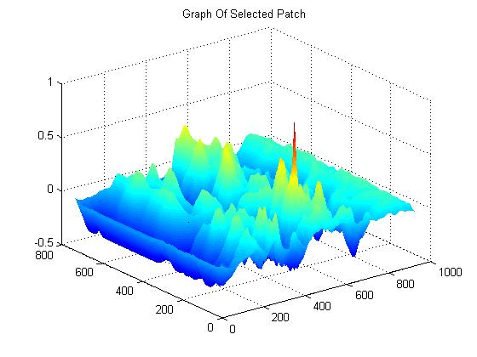
The approach as the above was used this time. Nevertheless, this was used to apply normalized cross correlation on the strip within the whole image.
%Using different templates "patches" from the gray scale image.
%Strong Edge Patch

patch1 = IGray(100:150, 200:250);
templates(patch1, IGray);
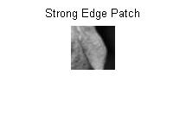
suptitle('Finding Strong Edge Patch from Whole Image');
figure,imshow(patch2), title('Strong Edge Patch');
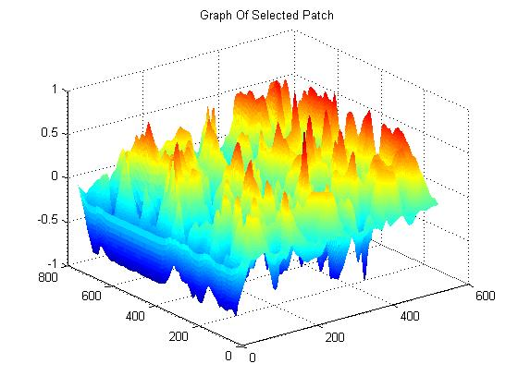

Using the templates function, we proceeded to test different type of templates “patches.” This first test was manually picked, and an edge was purposely picked to be able to establish a difference between this type of patch and any other.


%Strong Edge Patch
patch1 = IGray(300:350, 300:350);
templates(patch1, IGray);
suptitle('Finding Strong Edge Patch from Whole Image');
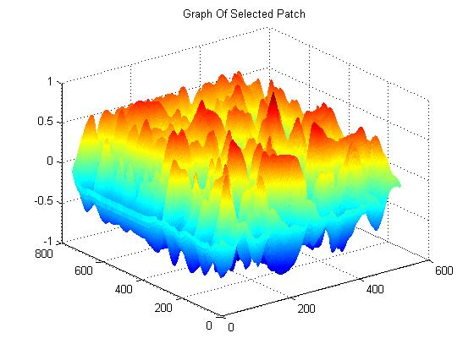
figure,imshow(patch3), title('Strong Edge Patch');
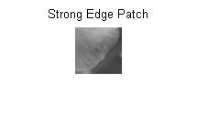
This is another example with a different patch. However, the approach is similar to the one above since it is also an edge and it was purposely manually assigned as well.
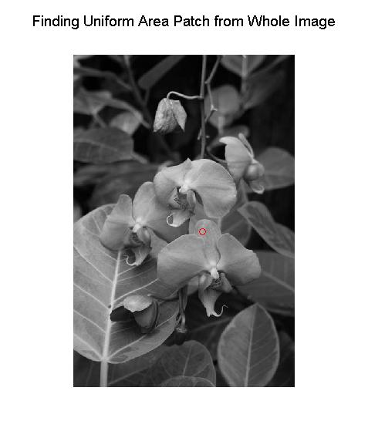
%Uniform Area Patch
patch1 = IGray(350:400, 250:300);
templates(patch1, IGray);
suptitle('Finding Uniform Area Patch from Whole Image');
figure,imshow(patch1), title('Uniform Area Patch');
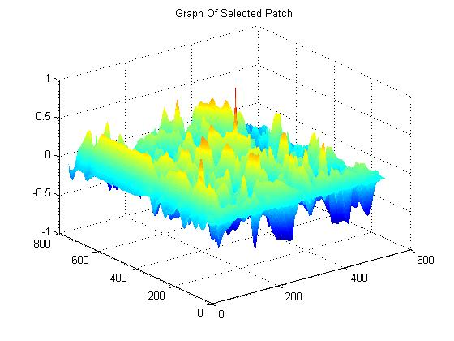
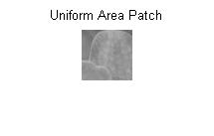

Using the templates function, we proceeded to test different type of templates “patches.” This test was manually picked, and it was picked from a uniform area to be able to establish a difference between this type of patch and any other.


%Uniform Area Patch
patch1 = IGray(10:80, 10:90);
templates(patch1, IGray);
suptitle('Finding Uniform Area Patch from Whole Image');
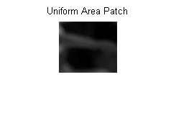
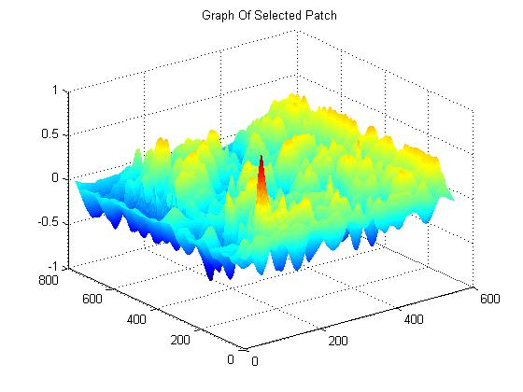
figure,imshow(patch1), title('Uniform Area Patch');
This is another example with a different patch. However, the approach is similar to the one above since it is also an edge and it was purposely manually assigned as well.

The Normalized Cross Correlation function set to 0 all locations from positions where the assigned patch and the image overlap less than the required number of overlap pixels. Larger values of required number of pixels zero-out pixels on a larger border. As observed by the graphs, larger values removed less stable computations but also limited the capture range.

Some limitations of the Normalized Cross Correlation function are the followings:

The documentation of normxcorr2 states that, "The matrix A must be larger than the matrix TEMPLATE for the normalization to be meaningful." It is implemented following the details of the paper "Fast Normalized Cross-Correlation", by J. P. Lewis, Industrial Light & Magic. This approach assumes the template is small relative to the image and proceeds to calculate the normalization across the entire template. This leads to correct computations wherever the template is wholly overlapping with the image, but the computation is incorrect in the borders of the output (the border size is proportional to the template size). This problem is therefore worse for larger templates to the point that, when the template is the same size as the image, the only correct value are at the center pixel (where the images are fully overlapping). Therefore, if the normalized cross correlation function is used for such things as registering images of the same size, the result will be incorrect.

What are the characteristics of ‘good’ templates?

Good templates are those that are larger than the matrix template for the normalization to be meaningful. If the template is smaller than the image and it is desired that the computation only be carried out when the template is fully overlapping the image, the required Number of Overlap Pixels should be set as those in the templates, This type of approach tends to give correct results everywhere regardless of the relative size of the patch and template. It accomplishes this by computing the normalized correlation only in the overlap regions between the two matrices. Thus, the result is correct for all locations of correlation. The result is the same as if the normalized cross correlation were carried out in the spatial domain, taking a long time to compute for large matrices.

